Project Design Phase-II
Data Flow Diagram & User Stories

Date | 22 February 2026
Team ID | LTVIP2026TMIDS24072
Project Name | ShopEZ:One-Stop Shop for Online Purchases
Maximum Marks | 4 Marks

Data Flow Diagrams:
A Data Flow Diagram (DFD) is a traditional visual representation of the information flows within a system. A neat and clear DFD can depict the right amount of the system requirement graphically. It shows how data enters and leaves the system, what changes the information, and where data is stored.

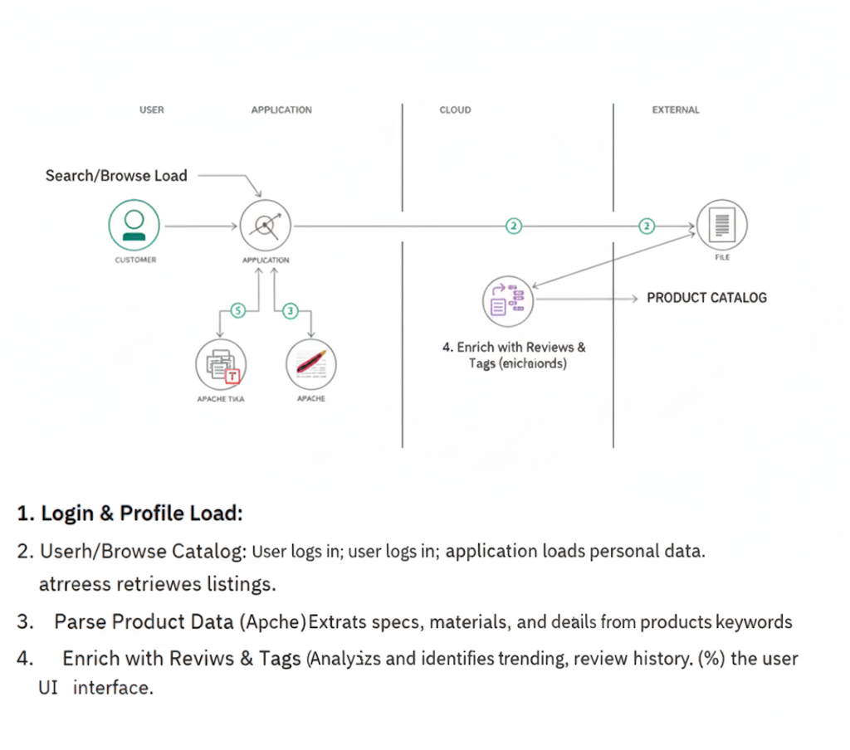

User Stories
Use the below template to list all the user stories for the product.
User Type | Functional Requirement (Epic) | User Story No | User Story / Task | Acceptance Criteria | Priority | Release
Customer (Mobile) | Registration | USN-1 | As a user, I can register using email and password | User is redirected to dashboard after successful registration | High | Sprint-1
 |  | USN-2 | As a user, I receive confirmation email after registration | User receives email & can verify account | High | Sprint-1
 |  | USN-3 | As a user, I can register using Facebook | User can login via Facebook & access dashboard | Low | Sprint-2
 |  | USN-4 | As a user, I can register using Gmail | User can login via Gmail & access dashboard | Medium | Sprint-1
 | Login | USN-5 | As a user, I can login using email & password | User can access dashboard after valid login | High | Sprint-1
 | Product Browsing | USN-6 | As a user, I can browse products by category | Products are displayed based on selected category | High | Sprint-1
 | Search & Filter | USN-7 | As a user, I can search products using keywords | Relevant products appear based on search | High | Sprint-1
 | Cart | USN-8 | As a user, I can add products to cart | Product appears in cart with correct price | High | Sprint-1
 | Checkout | USN-9 | As a user, I can proceed to checkout | User can complete payment successfully | High | Sprint-1
 | Order Tracking | USN-10 | As a user, I can track my orders | Order status is visible in account section | Medium | Sprint-2

